CSE 581

**Lab 17: Performance tuning with Indexes.**

*Do this against YOUR own database.*

***For the entire lab, provide all of your SQL as text, inserted at the beginning of the document.***

***For each step also provide a screenshot of execution, showing the SQL and the results.***

***Finally, provide the raw data as well as your calculation, highlighting the final result.***

**Steps:**

1. Create the following table:

CREATE TABLE TestForIndex

(

TestID INT PRIMARY KEY,

Column1 INT NOT NULL

);

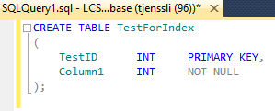

1. Write a stored procedure that will insert 1 million records into the TestForIndex table. The values[1] for both testId and column1 should start at 0 and increase by 1.

CREATE PROCEDURE TestForIndexRecords AS

BEGIN

DECLARE @Data INT

DECLARE @Count INT

SELECT @Count = 0 --init count

WHILE (@Count < 1000000)

BEGIN

SELECT @Data = @Count --increments with count

INSERT INTO TestForIndex(TestID,Column1)

VALUES (@Count,@Data) -- store new values in the table

SELECT @Count = @Count + 1 --increment count and therefroe data

END

UPDATE TestForIndex --update the table, reset column1 and testid

SET Column1 = 0

WHERE TestID = 0

END;

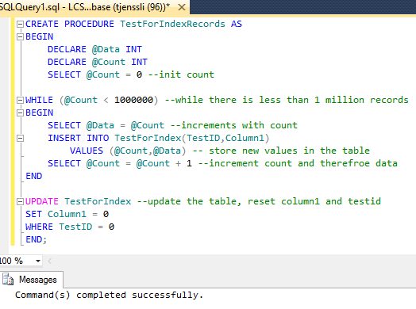

1. Execute the SP. Once it finishes running, verify that the data was inserted.

EXEC dbo.TestForIndex

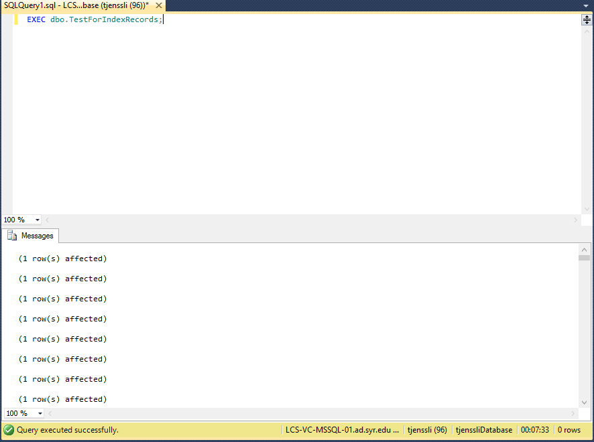

1. Run the following selects from the table, take note of the time it took to select the data. Run each statement 10 times, Average out the rest of the runs (for both the CPU time and the overall times).

SET STATISTICS TIME ON

SELECT *

FROM TestForIndex a, TestForIndex b

WHERE a.testID = b.column1;

SET STATISTICS TIME OFF

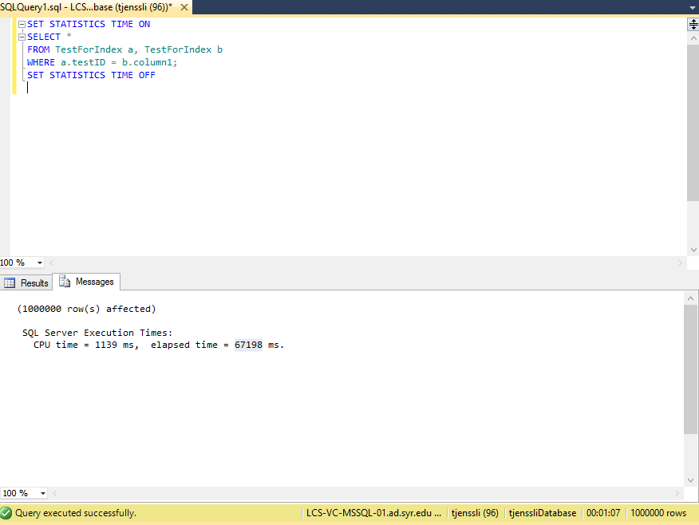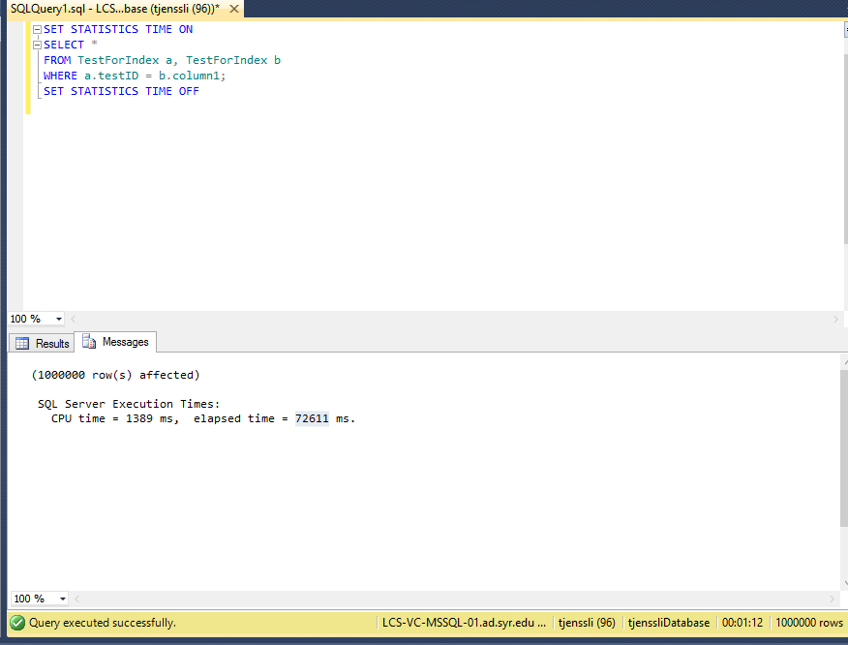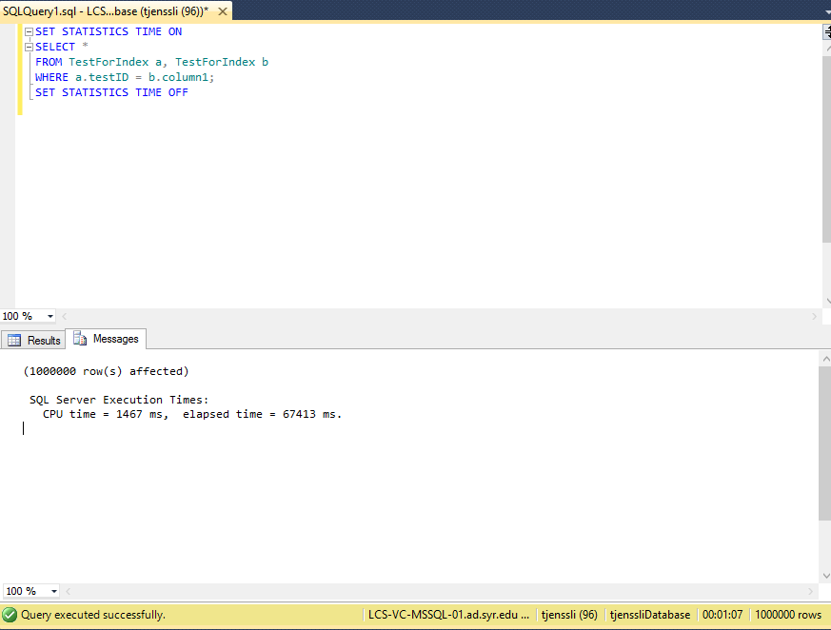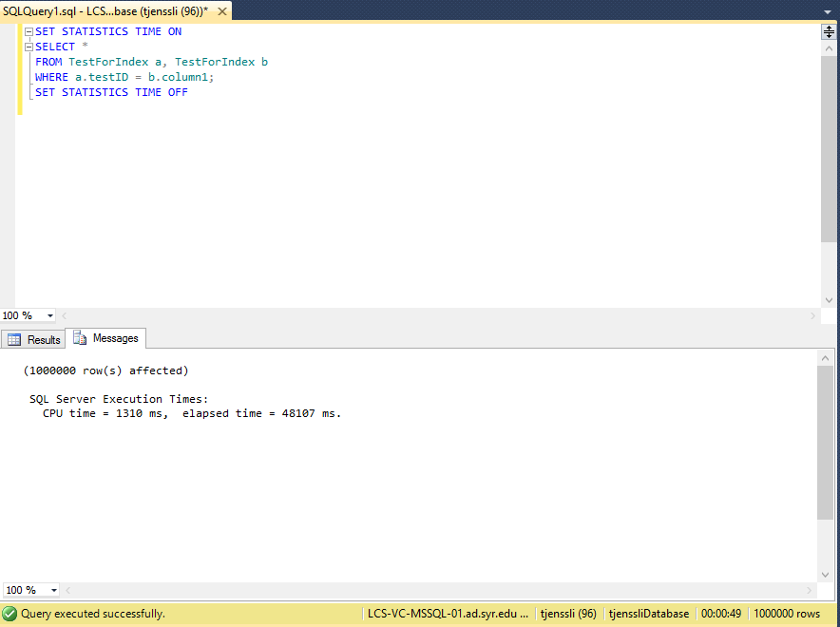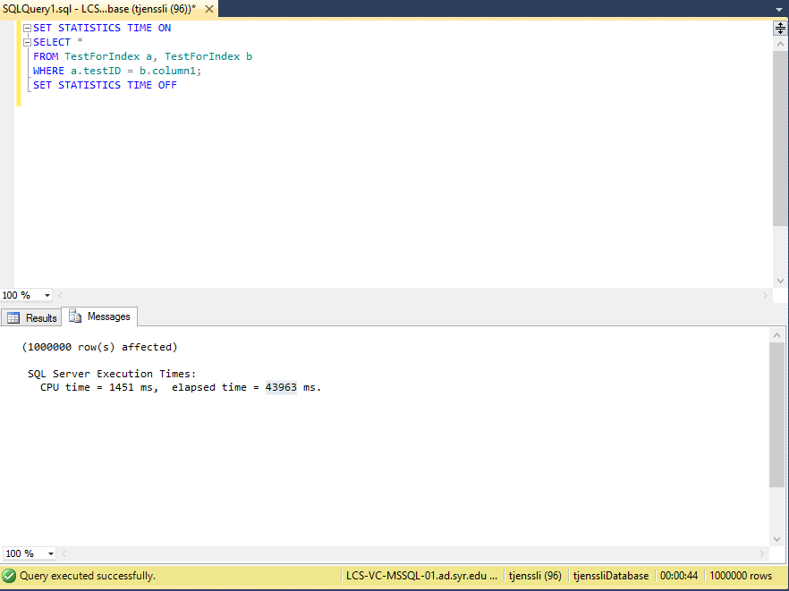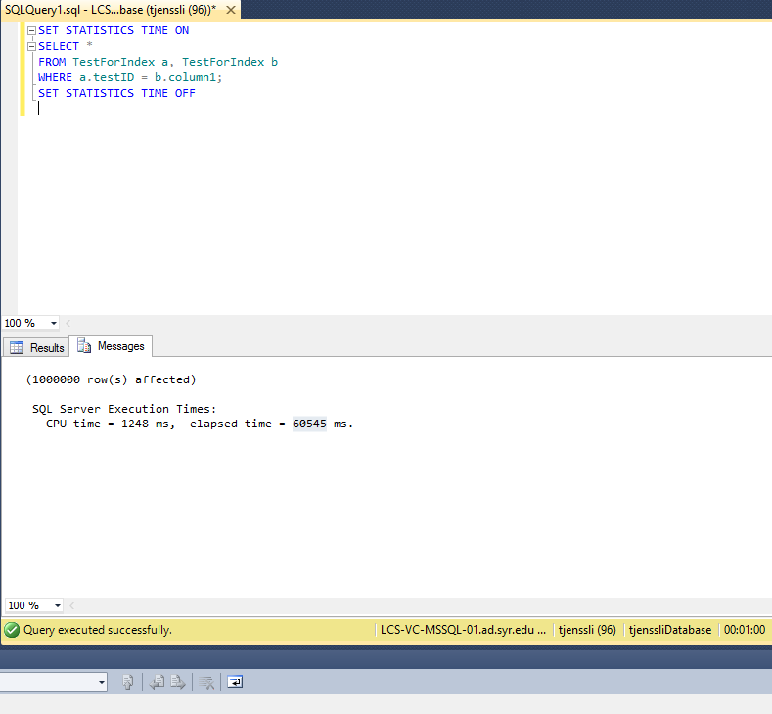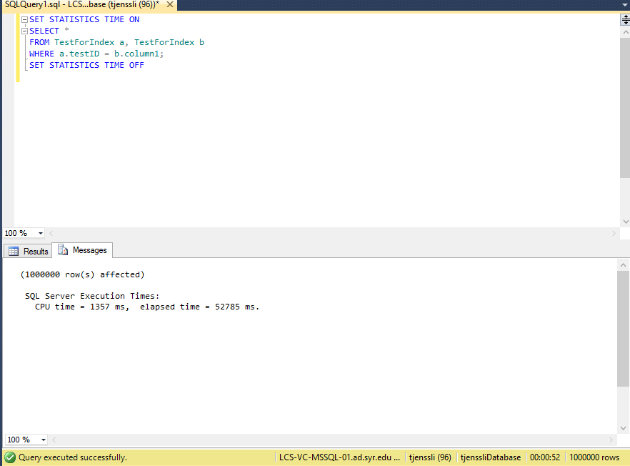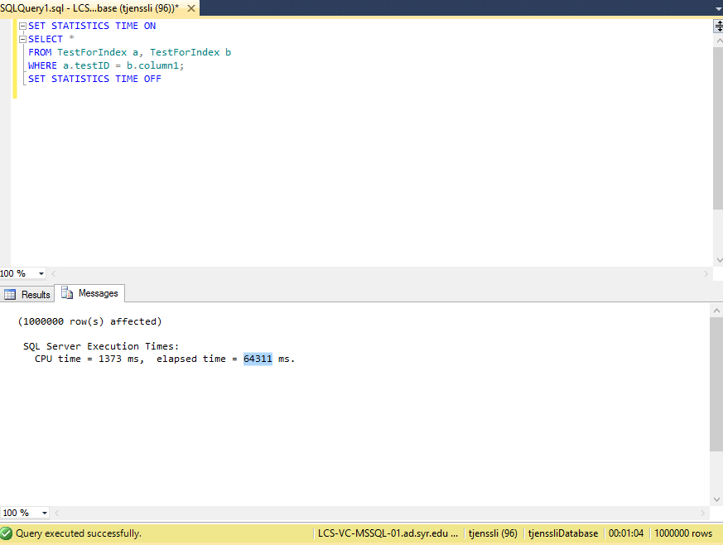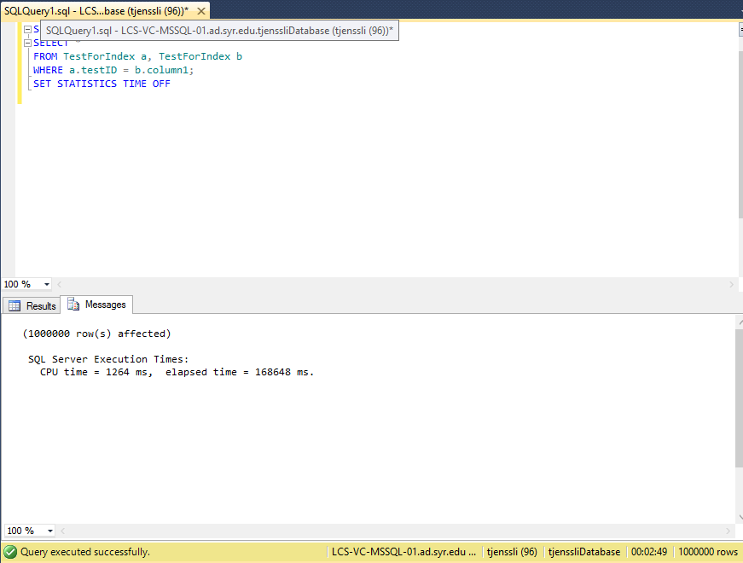

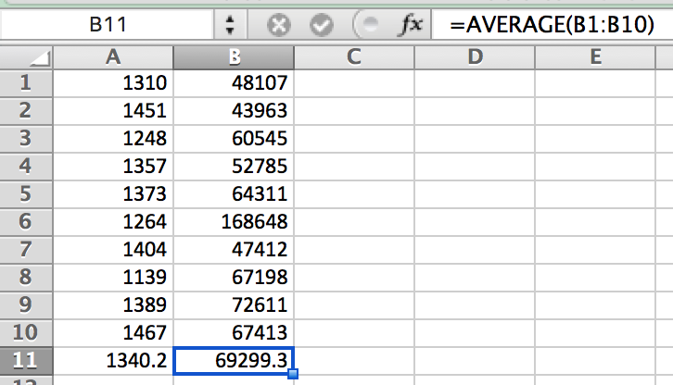

Average CPU Time: 1340.2 ms

Average Elapsed Time: 69299.3 ms

1. Create an index on the column1 column.

CREATE INDEX ColumnOnIndex

ON TestForIndex(column1);

1. Run the selects again, following the same process as in #4.

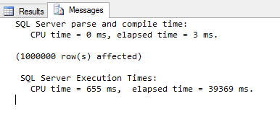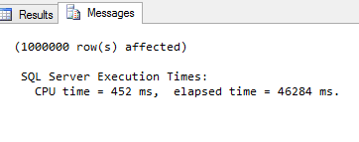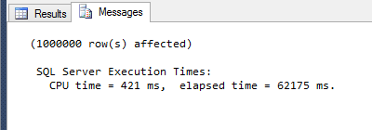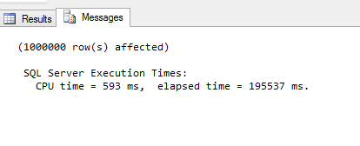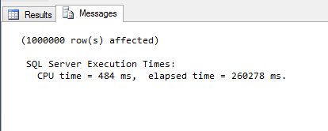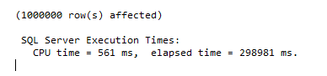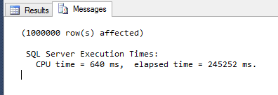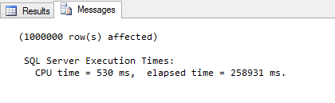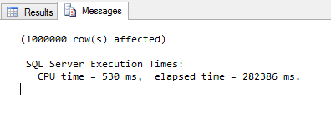

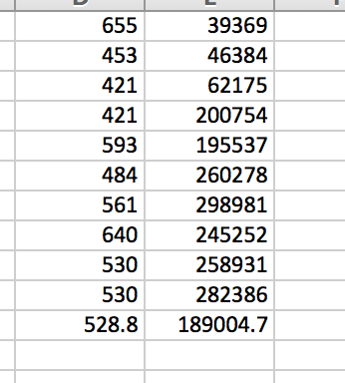

Average Indexed CPU Time: 528.8 ms

Average Indexed Elapsed Time: 189004.7 ms

1. Compute the difference (percentage change and actual change) between the indexed and non-indexed runs. Make sure that the performance increased as expected.

NON INDEXED:

Average CPU Time: 1340.2 ms

Average Elapsed Time: 69299.3 ms

INDEXED:

Average Indexed CPU Time: 528.8 ms

Average Indexed Elapsed Time: 189004.7 ms

CPU Percentage Change: 60.54 %

Elapsed Time Percentage Change: 172.73 %

1. Sample data: testId = 0, column1 = ***0***; testId = 1, column1 = 1; testId = 2, column1 = 2; …